Instructor: Dr. Jie Shen
Release date: Month. 01, 2021
Due date: Month. 08, 2021

Student Name: Demetrius Johnson
*Special note: see my lab uploads of the .CPP and .EXE files for ease of access and testing any of the programs for any question.

Table of Contents
Question 1 3
Source code (USED C++ COMPILER on Microsoft Windows 10) 3
Test data and expected results 4
Question 2 6
Source code (USED C++ COMPILER on Microsoft Windows 10) 6
Test data and expected results 8
Question 3 10
Source code (USED C++ COMPILER on Microsoft Windows 10) 10
Test data and expected results 12
Submission 14
Provide an MS word document or a pdf file with the following information: 14

Question 1

Source code (USED C++ COMPILER on Microsoft Windows 10)
// CIS-200-LAB_6-DemetriusJohnson.cpp : This file contains the 'main' function. Program execution begins and ends there.
//

/*
//Author: Demetrius E Johnson
//Date: 08 MONTH 2021
//Last Modification Date: 03-08-2021
//Purpose: test the use of a recursive function

*/

/*
Question 1:

Write a recursive function defined by the following recursive formula:

foo (Y, X) =
Y if X = 1
1 if X = Y
(foo ( Y-1, X-1) + 4* foo ( Y-1, X)) if Y > X > 1

Write a driver to print out the value for foo (5, 3) and foo (6, 5).

In addition, print out the total number of recursive function calls in each case.

*/

#include <iostream>
//#include<assert.h>
using namespace std;

//FUNCTION DECLARATIONS

int recursiveFunction(int Y, int X, int& numRecFunc_calls);

//FUNCTION DECLARATIONS

int main()
{
int numberOfRecFCalls = -1; //first call will cause this to go to 0; the first call is not a recursive call

cout << "-----WELCOME: This program tests the use of a recursive function ----by Demetrius Johnson\n\n\n";

cout << "Output for recursive function calls for input (5, 3): " << recursiveFunction(5, 3, numberOfRecFCalls) << endl;
cout << "Number of recursive calls of the function: " << numberOfRecFCalls;

numberOfRecFCalls = -1;
cout << "\n\nOutput for recursive function calls for input (6, 5): " << recursiveFunction(6, 5, numberOfRecFCalls) << endl;
cout << "Number of recursive calls of the function: " << numberOfRecFCalls;

cout << endl << endl << "The program has finished execution....now exiting...thank you....\n\n";
system("pause");

return 0;
}

//FUNCTION DEFINITIONS BELOW THIS LINE

int recursiveFunction(int Y, int X, int& numRecFunc_calls) {

numRecFunc_calls++;
if (X == 1) { return Y; }
if (X == Y) { return 1; }
if(X > 1 && X < Y) { return recursiveFunction((Y - 1), (X - 1), numRecFunc_calls) + (4 * recursiveFunction(Y - 1, X, numRecFunc_calls)); }

}

Test data and expected results

Test Table:
Test # | Valid / Invalid Data | Description of test | Input Value | Expected Output | Actual Output | Test Pass / Fail
1 | valid | Test recursive function | (5,3) | Output 67; number of recursive calls: 10 | See screenshot | pass
2 | valid | Test recursive function | (6,5) | Output 18; number of recursive calls: 8 | See screenshot | pass

TEST 1:
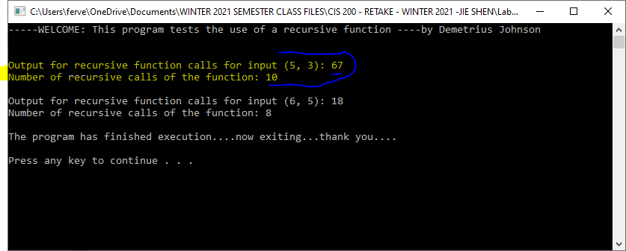
TEST 2:

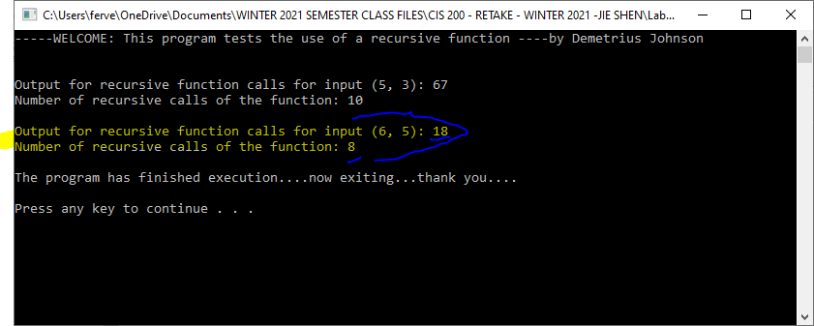

Question 2

Source code (USED C++ COMPILER on Microsoft Windows 10)
// CIS-200-LAB_6-DemetriusJohnson.cpp : This file contains the 'main' function. Program execution begins and ends there.
//

/*
//Author: Demetrius E Johnson
//Date: 08 MONTH 2021
//Last Modification Date: 03-08-2021
//Purpose: implement a recursive function that conducts a binary search

*/

/*
Question 2:

Implement a recursive function that conducts a binary search with the following interface:

bool BinarySearch (int info[ ], int x, int fromLoc, int toLoc, int &step);
// info[fromLoc, toLoc] stores an ordered list
// step: the number of search step of this binary search
// x -- a search item
// if x is in the list, return true; otherwise, return false

Test cases:
#define LEN 10000
int info[LEN];
for(int i=0; i< LEN; i++)
info[i] = i;

int step;

cout << BinarySearch(info, 997, 0, LEN-1, step) << endl;
cout << “Binary search steps: “ << step << endl;

cout << BinarySearch(info, 20000, 0, LEN-1, step) << endl;
cout << “Binary search steps: “ << step << endl;

*/

#include <iostream>
#define LEN 10000
//#include<assert.h>
using namespace std;

//FUNCTION DECLARATIONS
bool BinarySearch(int info[], int x, int fromLoc, int toLoc, int& step);
//FUNCTION DECLARATIONS

int main()
{

cout << "-----WELCOME: This program tests the implementation of a recursive function that conducts a binary search.\n----by Demetrius Johnson\n\n";
cout << "Note that the Time Complexity for a binary search is log_2(N)\n\n\n";
int info[LEN];

for (int i = 0; i < LEN; i++) { info[i] = i; } //set every element of the array equal to its element position (0 - 9999)

int step = 0; //initiate step counter to 0 steps --> first call to binarySearch recursive function

cout << "For binary search of 9997 from sorted info array 0-9999 ";
cout << "(True = 1 or False = 0): " << BinarySearch(info, 9997, 0, LEN - 1, step) << endl << endl;
cout << "Binary search steps: " << step << endl << endl;
cout << "Expected binary search steps based on known Time Complexity of log_2(N): log_2(9997) = 13.287\n\n\n\n\n";

step = 0; //reset step counter
cout << "For binary search of 20000 from sorted info array 0-9999 ";
cout << "(True = 1 or False = 0): " << BinarySearch(info, 20000, 0, LEN - 1, step) << endl << endl;
cout << "Binary search steps: " << step << endl << endl;
cout << "Expected binary search steps based on known Time Complexity of log_2(N): log_2(10000) = 13.287; \n20000 is not in the array so expect search to be worst case.\n\n";

cout << endl << endl << "The program has finished execution....now exiting...thank you....\n\n";
system("pause");

return 0;
}

//FUNCTION DEFINITIONS BELOW THIS LINE

// info[fromLoc, toLoc] stores an ordered list
// step: the number of search step of this binary search
// x -- a search item
// if x is in the list, return true; otherwise, return false

bool BinarySearch(int info[], int x, int fromLoc, int toLoc, int& step) {

int midPoint = (fromLoc + toLoc) / 2; //set new midpoint every time this function is called using the passed in from and to location values
int From_To_Distance = toLoc - fromLoc;
step++; //increase by the number of times this function is called

if (x == info[midPoint]) { return true; }

if (x > info[midPoint] && From_To_Distance > 1) { //ensure from and to location difference is greater than 1 so that the function will not loop

fromLoc = midPoint;
return BinarySearch(info, x, fromLoc, toLoc, step);
}

if (x < info[midPoint] && From_To_Distance > 1) { //ensure from and to location difference is greater than 1 so that the function will not loop

toLoc = midPoint;
return BinarySearch(info, x, fromLoc, toLoc, step);
}

if (From_To_Distance < 2) { //need this for the case where FROM and TO is a difference of only 1 or 0 in terms of position;
//EXAMPLE: (1+2)/2 = 1 --> (1+2)/2 = 1....repeating from above functions assigning from and to and a new midpoint that will keep resulting in 1; same scenario for FROM = TO.

if (x == info[fromLoc] || x == info[toLoc]) { return true; }
else { return false; }

} //value not found case (or valued found at the last two locations to search)
}

Test data and expected results

Test Table:
Test # | Valid / Invalid Data | Description of test | Input Value | Expected Output | Actual Output | Test Pass / Fail
1 | valid | Test binary recursive search function | 9997 | True (1),steps = 13 | See screenshot | pass
2 | valid | Test binary recursive search function | 20000 | False (0),steps = 15 | See screenshot | pass

TEST 1:
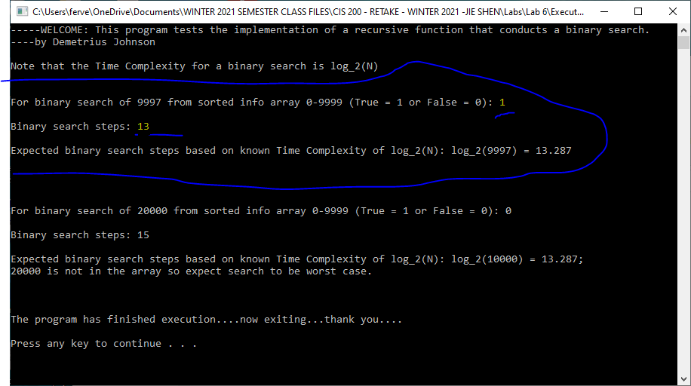
TEST 2:

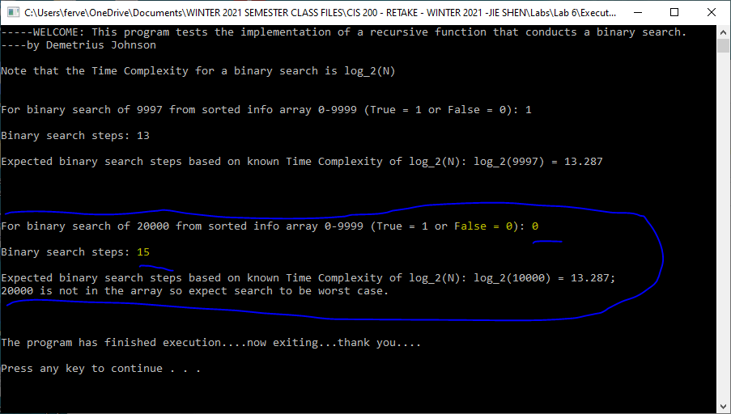

Question 3

Source code (USED C++ COMPILER on Microsoft Windows 10)
// CIS-200-LAB_6-DemetriusJohnson.cpp : This file contains the 'main' function. Program execution begins and ends there.
//

/*
//Author: Demetrius E Johnson
//Date: 08 MONTH 2021
//Last Modification Date: 03-08-2021
//Purpose: Show use of a Linear search

*/

/*
Question 3:

Implement a function that conducts a linear search with the following interface:

bool LinearSearch (int info[ ], int x, int fromLoc, int toLoc, int &step);
// info[fromLoc, toLoc] stores an ordered list
// step: the number of search step of this linear search
// x -- a search item
// if x is in the list, return true; otherwise, return false

Test cases:
#define LEN 10000
int info[LEN];
for(int i=0; i< LEN; i++)
info[i] = i;

int step;

cout << LinearSearch(info, 997, 0, LEN-1, step) << endl;
cout << “Linear search steps: “ << step << endl;

cout << LinearSearch(info, 20000, 0, LEN-1, step) << endl;
cout << “Linear search steps: “ << step << endl;

*/

#include <iostream>
#define LEN 10000
//#include<assert.h>
using namespace std;

//FUNCTION DECLARATIONS
bool LinearSearch(int info[], int x, int fromLoc, int toLoc, int& step);
//FUNCTION DECLARATIONS

int main()
{

cout << "-----WELCOME: This program tests the implementation of a linear function that conducts a linear search.\n----by Demetrius Johnson\n\n";
cout << "Note that the Time Complexity for a linear search O(N)\n\n\n";
int info[LEN];

for (int i = 0; i < LEN; i++) { info[i] = i; } //set every element of the array equal to its element position (0 - 9999)

int step = 0; //initiate step counter to 0 steps --> first call to linearSearch function

cout << "For linear search of 9997 from sorted info array 0-9999 ";
cout << "(True = 1 or False = 0): " << LinearSearch(info, 9997, 0, LEN - 1, step) << endl << endl;
cout << "Linear search steps: " << step << endl << endl;
cout << "Expected linear search steps based on known Time Complexity of O(N): 9998 (0 to 9997 --> 9998 steps)\n\n\n\n\n";

step = 0; //reset step counter
cout << "For linear search of 20000 from sorted info array 0-9999 ";
cout << "True = 1 or False = 0: " << LinearSearch(info, 20000, 0, LEN - 1, step) << endl << endl;
cout << "Linear search steps: " << step << endl << endl;
cout << "Expected linear search steps based on known Time Complexity of O(N): 10000. \n20000 is not in the array so expect search to be worst case.\n\n";

cout << endl << endl << "The program has finished execution....now exiting...thank you....\n\n";
system("pause");

return 0;
}

//FUNCTION DEFINITIONS BELOW THIS LINE

// info[fromLoc, toLoc] stores an ordered list
// step: the number of search step of this linear search
// x -- a search item
// if x is in the list, return true; otherwise, return false

bool LinearSearch(int info[], int x, int fromLoc, int toLoc, int& step) {

for(int i = fromLoc; i <= toLoc; i++){

step++;
if (x == info[i]) { return true; }
if (i == toLoc) { return false; } //if i increments all the way to toLoc without finding a match from the statement above this, then value is not found so return false

}

}

Test data and expected results

Test Table:
Test # | Valid / Invalid Data | Description of test | Input Value | Expected Output | Actual Output | Test Pass / Fail
1 | valid | Test linear search function | 9997 | True (1),steps = 9998 | See screenshot | pass
2 | valid | Test linear search function | 20000 | False (0),steps = 10000 | See screenshot | pass

TEST 1:
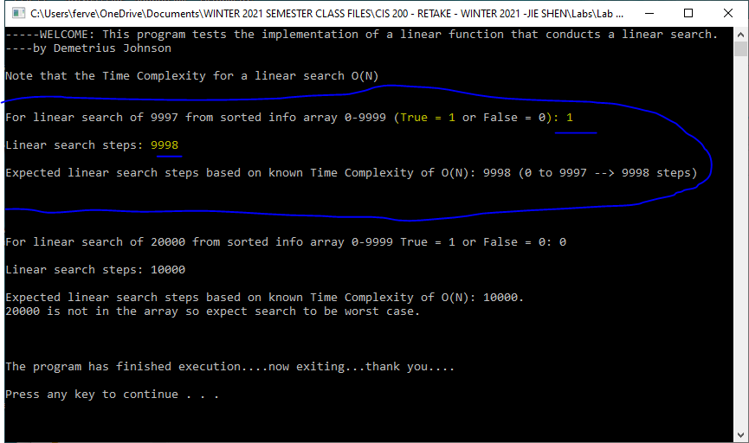

TEST 2:
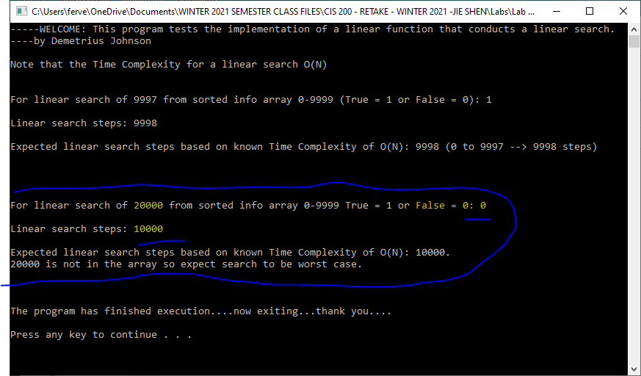

Submission

Provide an MS word document or a pdf file with the following information:
- Cover page with lab number and title, your name, date
- Test data and expected results
- Running log/output (screen shots should be provided)
- Insert the source code and screenshots into the word document
- You should submit your work through Canvas site for cis 200 lab.
- The filename of the word document should follow the convention: FirstName_LastName_Cis200Lab3.doc or pdf.

